**Git & Github All Interview Questions**

1. What is the difference between Git and Github?

Ans :

1. What is Git Repository?

Ans : 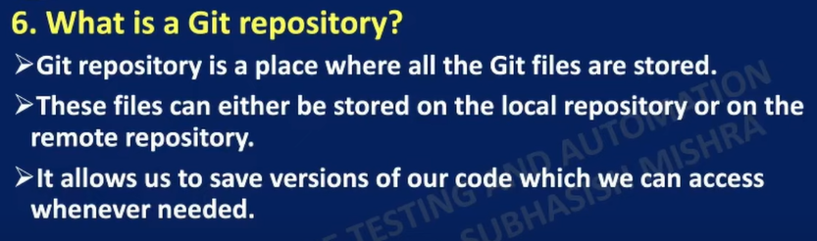

1. How can you initialize a repository in Git?

1. What are the states of a file in Git?

1. What is Staging Area in Git?

Ans :

1. Name a few Git command with their usage.

Ans :

